**A Minor Project Report**

On

**“Maximum Power Point Tracking”**

Submitted in fulfilment of

**Minor Project (EEP 354)**

by

### Ashish Singhal (Roll No. 191230016)

### Rahul Meena (Roll No. 191230036)

### Saurabh Yadav (Roll No. 191230044)

Supervisor:

# Dr. Pankaj Mukhija



Department of Electrical & Electronics Engineering

**NATIONAL INSTITUTE OF TECHNOLOGY DELHI**

# APPROVAL SHEET

This Minor Project work entitled “Maximum Power point Tracking” by Ashish Singhal (Roll No.: 191230016), Rahul Meena (Roll No.: 191230036), Saurabh Yadav (Roll No.191230044) is approved for the degree of Bachelor of Technology.

**Examiner**

.........................................

## Dr. Amit Kumar Singh

**Supervisor**

......................................

...

## Dr. Pankaj Mukhija

Date: .........................................

Place: ....................................

# DECLARATION

We declare that this written submission represents our ideas in our own words and where others' ideas or words have been included, we have adequately cited and referenced the original sources. We also declare that we have adhered to all principles of academic honesty and integrity and have not misrepresented or fabricated or falsified any idea/data/fact/source in our submission. We understand that any violation of the above will be cause for disciplinary action by the Institute and can also evoke penal action from the sources, which have thus not been properly cited, or from whom proper permission has not been taken when needed.

Date:

........................................... ........................................... ............................................

Ashish Singhal Saurabh Yadav Rahul Meena

(Roll No.: 191230016) (Roll No.: 191230044) (Roll No.: 191230036)

**Table of Contents**

|  |  |  |
| --- | --- | --- |
| Serial No. | Title | Page No. |
|  | ACKNOWLEDGEMENT | iv |
|  | ABSTRACT | v |
|  | LIST OF FIGURES | vi |
| 1. | Introduction   * 1. Photovoltaic system   2. System Component   3. Inverter   4. Racking   5. Other Component   6. PV System types and components   7. Types of power converter | 1-10 |
| 2. | MPPT Concept and Algorithm  2.1 Smart power tracker  2.2 Perturb and Observe technique  2.3 Incremental conductance method  2.4 Fuzzy logic algorithm | 11-19 |
| 3. | Controller and Results | 20-24 |
| 4. | Conclusion | 25 |
| 5. | References | 26 |

# ACKNOWLEDGEMENT

This project has received guidance from the Electrical and Electronics Engineering research and innovation program under the honorable guidance of the Head of Department, EEE.

The electrical equipment, space for project development, and resources required have been properly taken care of by the faculty supervisor and mentor Dr. Pankaj Mukhija.

This is to acknowledge all those without whom this project would not have been a reality. Firstly, I would like to thank our Faculty Supervisor, Dr. Pankaj Mukhija who gave his immense support, dedicated his time to it and made us understand how to do this project. Without his guidance, the project would not have been complete.

The matter contained in it has been widely taken from reference research papers and the Internet. The source of the newspaper article is The Independent, and the statistical data has been extracted from the university and research paper-provided database.

While we were preparing this project file, various information we found helped us throughout and we are glad that we were able to complete this project and understand many things. The preparation of this computer science project was an immense learning experience and we inculcated many personal qualities during this process like responsibility, punctuality, confidence, and others.

We would like to thank our EEE faculty members who supported us all the time and cleared our doubts, and our parents who also played a big role in the finalization of our project file. We are taking this opportunity to acknowledge their support and we wish that they keep supporting us like this in the future.

Ashish Singhal (Roll no.-191233016)

Rahul Meena (Roll no.-191230036)

Saurabh Yadav (Roll no.-191230044)

**ABSTRACT**

This project report presents maximum power point tracking concept (MPPT) with the help of different algorithms i.e perturb and observe technique, swarm particle optimization technique etc. The simulation has been done by using MATLAB and results are verified successfully. Apart from conventional techniques, two new theoretical methods are also applied for MPPT optimization. This report also highlights the use of different essential equipment’s like- controllers, converters etc.

**LIST OF FIGURES**

|  |  |  |  |  |
| --- | --- | --- | --- | --- |
| Figure No. | Title of figure | | | Page No. |
| 1.1 | Photovoltaic Grid | | | 2 |
| 1.2 | Solar cells | | | 2 |
| 1.3 | Solar panel system | | | 3 |
| 1.4 | PV system flow graph | | | 5 |
| 1.5-1.8 | PV module and components | | | 6-8 |
| 1.9 | Converter | | | 9 |
| 1.10 |  | Boost Converter |  | 10 |
| 2.1 | Array IV curve | | | 12 |
| 2.2 | Maximum power point | | | 14 |
| 2.3 | Flow graph | | | 15 |
| 2.4 | Fuzzy logic controller | | | 18 |
| 2.5 | Fuzzy logic MPPT block | | | 18 |
| 3.1 | Elements of PID controller | | | 19 |
| 3.2 | PID controller | | | 20 |
| 3.3 | P&O MTALAB Simulink | | | 20 |
| 3.4 | Input/output voltage, current and power waveform | | | 21 |
| 3.5 | Fuzzy logic controller MATLAB Simulink | | | 23 |
| 3.6 | Voltage and current measurement | | | 23 |
| 3.7 | Output voltage and PWM waveform | | | 24 |
| 3.8 | Output voltage waveform | | | 24 |

**CHAPTER-1**

**INTRODUCTION**

The relationship between a photovoltaic cell's operating environment and the power it generates is complicated. The fill factor (FF) describes the nonlinear electrical behaviour of the cell. The ratio of a cell's maximal power to the sum of its open-circuit voltage and short-circuit current is known as the fill factor. Tabulated data is frequently used to calculate the maximum power that a cell can deliver under specific circumstances with an ideal load: display style P=FF*Voc*Isc where FF , Voc, and Isc are typically sufficient to provide a meaningful approximation of the electrical behaviour of the cell under usual circumstances. The operating point of the panel is rarely at peak power when a load is connected directly to the cell. The operating point of the panel is determined by the resistance it perceives. Peak power is attained by correctly setting the impedance. DC-DC converters change the impedance of one circuit (source) to the other circuit since panels are DC devices (load). The impedance (duty ratio) that the cell perceives changes when the DC-DC converter's duty ratio is altered. The irradiance and temperature of the atmosphere can have a significant impact on the panel's I-V curve. Panel voltages and currents are frequently sampled using MPPT algorithms, and the duty ratio is then adjusted as necessary. The algorithms are implemented by microcontrollers. More advanced computers are frequently used in modern systems for analytics and load forecasting. Various techniques has been used for obtaining maximum power point i.e perturb and observe, incremental conductance, fuzzy control method etc. In the upcoming pages of this report we will be dealing with all the necessary components used to obtain MPPT.

**1.1 Photovoltaic system**

A photovoltaic (PV) system is composed of one or more solar panels combined with an inverter and other electrical and mechanical hardware that uses energy from the sun to generate electricity. PV systems can vary greatly in size from small rooftop or portable systems to massive utility scale generation plants. Although PV systems can operate by themselves as puff-grid PV systems. But, how do these systems work? The light from the Sun, made up of packets of energy called photons, falls onto a solar panel and creates an electric current through a process called the photovoltaic effect. Each panel produces a relatively small amount of energy but can be linked together with other panels to produce higher amounts of energy as a solar array. The electricity produced from a solar panel (or array) is in the form of direct current (DC). Although many electronic devices use DC electricity, including your phone or laptop, they are designed to operate using the electrical utility grid which provides (and requires) alternating current (AC). Therefore, for the solar electricity to be useful it must first be converted from DC to AC using an inverter. This AC electricity from the inverter can then be used to power electronics locally, or be sent on to the electrical grid for use elsewhere.

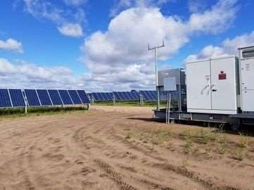

Fig.1.1 photovoltaic grid

**1.2 System components**

Other significant parts of a photovoltaic system, also known as the "balance of system" or BOS, exist in addition to the solar panels. These parts (which typically make up the majority of the system's cost and more than half of its Inverters, racking, wiring, combiners, disconnects, circuit breakers, and electric metres might all require maintenance.

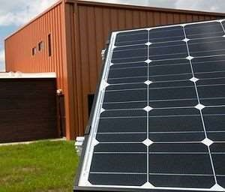

Fig.1.2 Solar Cells

A solar panel is made up of several solar cells having semiconductor qualities that are encased in a covering to shield them from the elements. Due to these characteristics, the cell is able to absorb light, more precisely photons from the sun, and transform their energy into the photovoltaic effect, a process, generates usable electricity. A layer of conducting material “collects” the generated electricity on either side of the semiconductor. To reduce reflection-related losses, the panel’s lit side also has an antireflection layer. Crystalline silicon, which has a theoretical efficiency limit of 33% for converting the Sun’s energy into electricity, is used to make the vast majority of solar panels manufactured globally. Higher operating efficiency semiconductor materials and solar cell technologies have been created, but their production costs are higher.

**1.3 Inverters**

An inverter is a type of electrical appliance that absorbs direct current (DC) electrical current and converts it to alternating current (AC). This means that in solar energy systems, the DC current coming from the solar array is routed through an inverter to change it into AC. To use the majority of electric gadgets or connect to the electrical grid, this conversion is required. Nearly all solar energy systems depend on inverters, which are often the most expensive component.

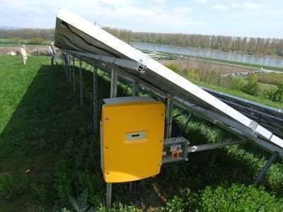

Fig.1.3 Solar Panel System

Most inverters have conversion efficiency of 90% or more and include crucial safety components like anti islanding and ground fault circuit interruption. When the grid power fails, these turn off the PV system.

**1.4 Racking**

The mounting system that secures the solar array to the ground or rooftop is referred to as racking. These devices, which are typically made of steel or aluminium, precisely mechanically fix the solar panels in place. Systems for racking should be built to endure storms with hurricane- or tornado-force winds, as well as heavy snowfall. In order to prevent electrocution, electrically bonding and grounding the solar array is a crucial component of racking systems. The two main types of rooftop racking systems are pitched roof systems and flat roof systems. It is typical for the racking system to have weighted ballast for flat rooftops so that gravity can hold the array to the roof. The racking system needs to be mechanically secured to the roof structure on sloped rooftops. Ballast or mechanical anchors can also be used in ground-mounted PV systems to secure the array to the ground. Some ground-mounted racking systems additionally include tracking mechanisms that follow the Sun's path through the sky using motors and sensors, boosting energy production at the expense of more expensive equipment and maintenance.

**1.5 Other Components**

Combiners, disconnects, breakers, metres, and wiring make up the remaining parts of a conventional solar PV system. As the name implies, a solar combiner joins two or more electrical cables together to create a single, longer cable. All medium to large and utility-scale solar arrays require combiners, which frequently have fuses for protection. Electrical gates or switches known as disconnects allow for the human cutting off of an electrical wire. The “DC disconnect” and “AC disconnect,” which are often utilised on either side of an inverter, offer electrical isolation when an inverter needs to be installed or updated. Electrical systems are shielded from surges or overcurrent by circuit breakers or breakers. Breakers can also be manually actuated, serving as an additional disconnect, but they are designed to activate automatically when the current reaches a certain value. Electric utility companies frequently utilise electric metres to gauge and bill their customers for the energy that flows through them. A specific bidirectional electric metre is used for solar PV systems to monitor both the energy coming in from the utility and the energy leaving the solar PV system.

**1.6 PV System Types and Components**

After this succinct introduction to PV technology and application, it is now time to go deeper into the system's constituent parts and discover the different kinds of systems that may handle different applications. we can see right once that different PV systems have different system components, sizes, and types of applications. For instance, rooftop solar systems for domestic use, where a grid is already in place, use components that are slightly different from solar water pumping systems for rural applications, where there is no access to a grid. What then are the primary types and elements that make up the PV system? In Figure1.5 we can see different types of PV configurations that work for both Grid connected and Stand-alone applications. We can see that the main difference between these two main types is utility grid availability.

**1.6.1 Stand-alone PV systems**

As depicted in Figure 1.8, all stand-alone (also known as off-grid) systems function in general without the utility grid. We anticipate a perfect match between supply and demand, or more specifically, between the size of the PV system and the required load. The PV system in this instance can be referred to as a "Direct-Coupled PV System" when this match is executed flawlessly for a single load, and relatively few components are required without the requirement for storage systems. A storage system is needed for a different kind of stand-alone so that extra energy can be captured when the sun is not shining and then used when it is unavailable. As we will discover later, this kind can be connected to AC loads directly or to DC loads via an additional power conditioning component known as a "Inverter." The "Hybrid PV System" is another popular type of stand-alone system that supplies loads in addition to the PV array using other energy sources. These power sources can include fuel cells, diesel generators, hydro turbines, wind turbines, and hydro turbines. Batteries are another option for energy storage in hybrid PV systems.

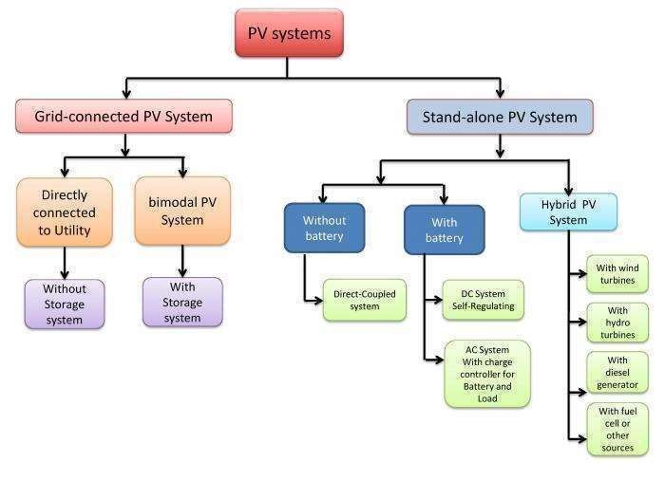

Fig. 1.4 PV systems flow graph

**1.6.2 Grid-Connected system**

For situations where customers wish to reduce their energy costs and while the utility grid is still available for usage when the PV array is not producing any electricity, this form of setup is the most typical. The term "Utility-Interactive PV System" or "Grid Tied PV System" refers to a PV array that can be directly connected to the grid without the use of a storage system. A "Bimodal PV System or Battery Backup PV System" is what it is known as when it has the ability to store excess energy into battery banks for later use. The article that follows explains the fundamentals of photovoltaic and how they operate while also providing a sample grid-connected PV system and a list of required parts. A variety of components are required to enable energy to be generated, conditioned, stored, and transmitted to end users in order for each of the PV system types we covered in this part to operate and offer useful energy to clients. What then are these generation, storage, and conditioning components as defined by the classification?

The main and only component in the PV system that converts solar radiation into electricity is the "Cell" or "Module."

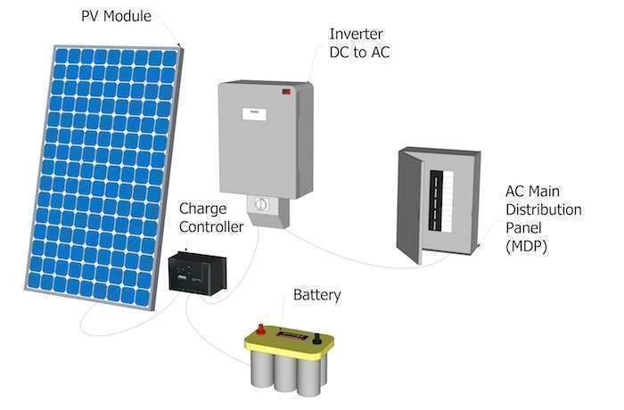

Fig.1.5 PV module and component

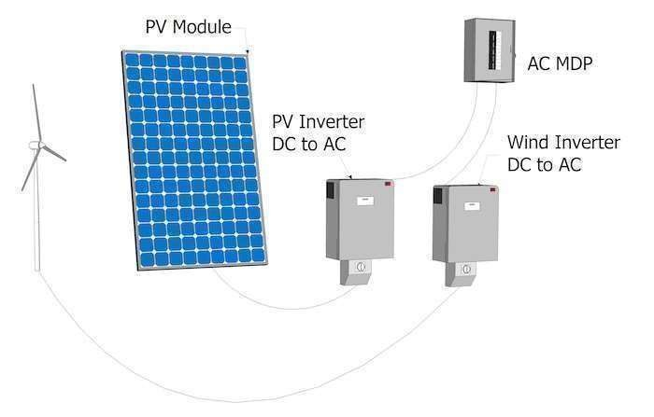

Fig.1.6 PV module and component

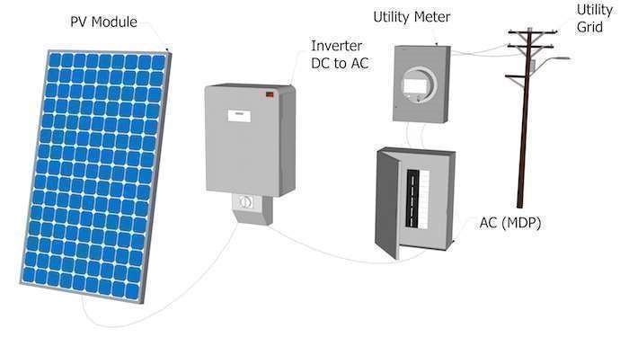

Fig.1.7PV module and component

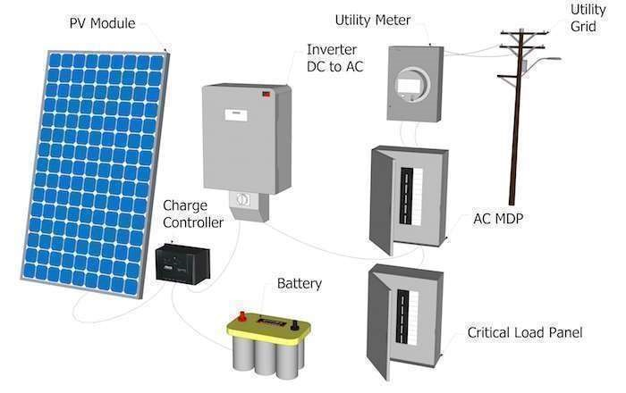

Fig.1.8 PV module and component

**1.6.3 Storage**

Not all energy the PV system generates is used right away, especially when we talk about off-grid systems. So in order for us to maximize the usage of the system, we need some devices to store the energy for later uses, and that is easily done using "Storage devices such as Batteries."

**1.6.4 Conditioning**

Solar PV generates DC electricity, which is not the common form to be used for home appliances and the utility grid in general, which usually uses AC electricity. So in order for us to be able to connect the PV system to the grid we need to change the DC to AC, and that is done using a power conditioning units AKA "inverter."

**1.7 There are mainly 4-Different types of Power Converters**

Power electronic converters are employed in all aspects of daily life, whether at home, at work, or in an industrial setting these converters are now a crucial component of industrial electric drives, high electric power sources, electric traction systems, and vehicle control equipment because of their high-power handling and higher efficiency different kinds of power electronic converters with wattages ranging from a few milli watts to a few thousand watts are available for carrying out various tasks (such as inversion, rectification, etc.). Let's examine these SCRs, TRIACs, IGBTs, and other power electronic components are used in power electronic converters to control and convert the electric power. The converter's primary goal is to generate conditioning power about a certain application.

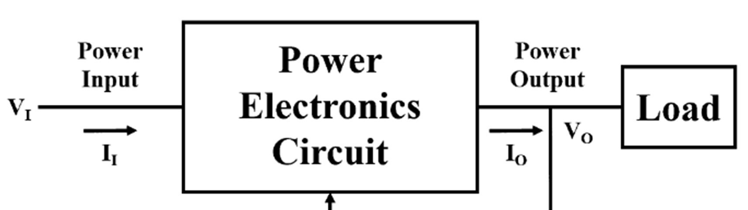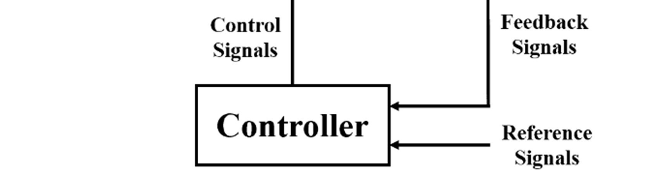

Fig.1.9 Converter

The figure above displays the block diagram of a power electronic converter. It consists of a power electronic circuit, a control circuit, an electric load, and an electrical energy source this converter transforms one kind of electrical energy into another kind power and control components jointly make up the power electronic circuit. The power portion, which includes power electronic switches (SCR or TRIAC), transformers, electric chokes, capacitors, fuses, and occasionally resistors, moves energy from the source to the load the elements of the converter's power section are controlled by the control circuit or block. This block is constructed using a sophisticated low power electronic circuit assembly, either analogue or digital power electronic converters carry out several fundamental power conversion tasks. Any task in an AC or DC power conversion system can be accomplished by this converter, which consists of just one power conversion stage. The following categories of power electronic converters are classed based on the type of function they perform. AC to DC = Rectifier: It converts AC to unipolar (DC) current DC to AC = Inverter: It converts DC to AC of desired frequency and voltage DC to DC = Chopper: It converts constant to variable DC or variable DC to constant DC AC to Switch mode power supplies (SMPS), electrical machine control, energy storage systems, lighting drives, active power filters, power generation and distribution, renewable energy conversion, flexible AC transmission, and embedded technology are just a few examples of the many applications where these kinds of power electronic converters are used.

**1.8 Step-up Chopper or Boost converter**

The output voltage in this chopper is always higher than the input voltage. The diagram below depicts how a boost converter is set up switch is employed in this instance as well, wired in parallel with the load. A thyristor or SCR is used in this switch a diode connected in series with the load enables the load current to flow even when the thyristor is switched off, much like the buck converter.

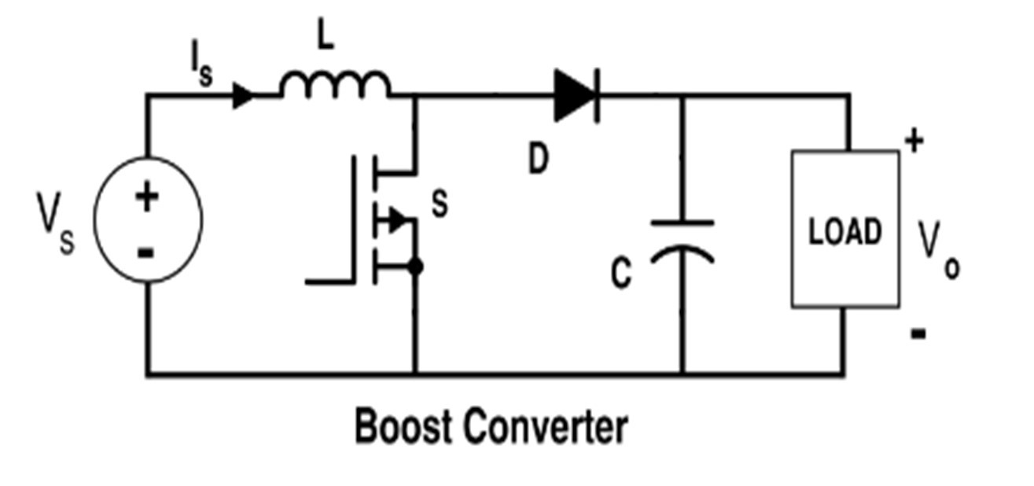

Fig.1.10 Boost Converter

The diode is reverse-biased when the thyristor is turned ON, which isolates the load circuit from the source. As a result, the inductor charges to the source of maximum input voltage the load receives the voltage from both the input and the inductor when the thyristor is switched OFF. Therefore, there will be a difference between the voltage across the converter's output and input here, the duty ratio (TON / T) is represented by d, and the output voltage is equal to (1/ 1 - d) times the input voltage. The output voltage will be adjusted by altering this duty ratio until the load receives the voltage.

**Chapter-2**

**MPPT CONCEPT AND ALGORITHMS**

What is Maximum PowerPoint Tracking? The word "tracking" is a little ambiguous: Panel tracking is the practice of mounting solar panels on a mount that moves with the sun. The Some works are the most prevalent. These maximize output by tracing the path of the sun across the sky to capture the most sunlight. These normally give you a rise of up to 35% in the summer and 15% in the winter for MPPT controllers, this is exactly the reverse of the seasonal variation. In the winter, panels produce more power since the temperatures are lower. Due to shorter days, winter is typically when you need your solar panels to produce the most power.

Maximum Power Point Tracking is a digital, electronic tracking method. The battery voltage is compared to the output of the panels by the charge controller. The best power that the panel can provide to charge the battery is then determined. To get the most AMPS into the battery, it takes this and transforms it to the best voltage. (Remember: Amps into the battery are what matter.) The majority of contemporary MPPTs have conversion efficiencies of 93–97%. In the winter, you normally gain 20 to 45% more power, and in the summer, 10-15% more. The actual gain can differ significantly based on the weather, temperature, battery charge, and other variables grid connection systems are growing in popularity as solar costs down and electricity prices rise. Gridtie only (i.e., no battery) inverters come in a variety of brands. These all have MPPT built in. The MPPT conversion on those operates with an efficiency of 94% to 97%.

**How Maximum Power Point Tracking works ?**

Here, the tracking or optimization of the maximum power point is relevant. Assume your battery has a 12-volt deficit. The battery now receives 10.8 amps at 12 volts after an MPPT converts the 17.6 volts at 7.4 amps. There are over 130 watts left, and everyone is happy while 11.3 amps at 11.5 volts would be ideal for 100% power conversion, you must feed the batteries a higher voltage to force the amps in. This is only a simplified description, as the MPPT charge controller's output may change continuously to ensure that the battery receives the maximum number of amps a screenshot of the "PV-Design Pro" computer programme by Maui Solar Software may be seen on the left (click on the picture for full-size image). The green line features a strong peak in the upper right corner, which signifies the moment of maximum power, if you look at it closely. An MPPT controller searches for that precise moment, then converts the voltage and current to meet the demands of the battery. That peak constantly shifts in real life as the weather and light conditions vary.

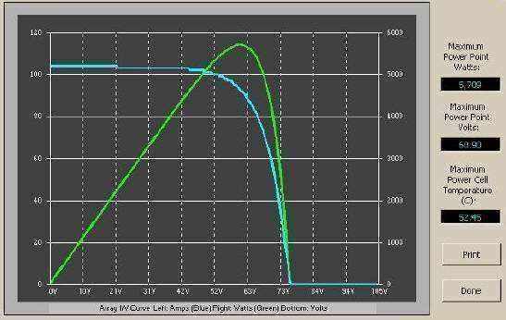

Fig.2.1 Array IV curve

In virtually all cases, an MPPT measures the maximum power point, which will differ from the STC (Standard Test Conditions) rating. A 120-watt panel can produce over 130+ watts at extremely cold temperatures since power output increases as panel temperature decreases. However, if you don't have a mechanism to monitor that power point, you risk losing it. On the other hand, when it is extremely hot outside, your power decreases; you lose power as the temperature rises. Because of this, you gain less during the summer the time of year when the extra electricity is needed the most is winter and/or overcast or hazy days.

1. Cold weather – solar panels perform better in colder temperatures, but you're losing the majority of that without an MPPT. Winter is when cold weather is more likely to occur since there are fewer hours of sunlight and a greater need for electricity to replenish batteries.

2. Low battery charge is another situation where the extra power is most necessary. The lower the state of charge in your battery, the more current an MPPT pumps into them. Both situations may exist simultaneously in you.

3. Long wire runs: If your panels are 100 feet away from a 12-volt battery that needs to be charged, the voltage drop and power loss could be significant without using extremely wide wire. That might be very pricey. However, the power loss is significantly reduced if four 12 volt panels are connected in series to create 48 volts, and the controller will reduce that high voltage to 12 volts at the battery. This also implies that you can utilize considerably lesser cable if your controller is fed by a high voltage panel configuration.

**What is an MPPT?**

**How a Maximum Power Point Tracker Works?**

It is a high-frequency DC to DC converter called the Power Point Tracker. To precisely match the solar panels to the batteries, they convert the DC input from the panels into high frequency AC, then alter it back to a different DC voltage and current. MPPTs function at very high audio frequencies, typically between 20 and 80 kHz. The ability to use very high efficiency transformers and compact components in the construction of high-frequency circuits is a benefit. High-frequency circuit design can be highly challenging due to issues with certain circuit elements "broadcasting" like radio transmitters, which interfere with radio and television signals. Isolation and suppression of noise become crucial there are a few linear, non-digital MPPT charge controls available. Compared to computerised ones, these are significantly simpler and less expensive to design and produce. They do, in fact, boost efficiency to some extent, but overall, there is a wide range of efficiency, and we have seen some lose their "tracking point" and even deteriorate. The linear circuit hunts for the next best spot but sometimes finds itself too far out in the deep end to find it again when the sun comes out. This can occasionally happen if a cloud passes over the panel. Thankfully, there aren't many of these lefts the power point tracker (and all DC-to-DC converters) work by converting the DC input current to AC, running it through a transformer (often a toroid, which has a doughnut-like shape), rectifying it back to DC, and then regulating the output. Except for minimal output voltage regulation, most DC-to-DC converters perform this function entirely electronically. The constant fluctuations in temperature, light, and battery voltage necessitate a lot more intelligence from charge controllers for solar panels.

**2.1 Smart power trackers**

The most recent digital MPPT controller versions on the market are all microprocessor controlled. They really shut down for a little period to "look" at the solar panel and battery and make any necessary modifications. They are aware of when to adjust the output that is being given to the battery. Electronic microprocessors are not particularly new—the Australian company AERL had several as early as 1985—but they have only lately become affordable enough to be useful in smaller systems (less than 1 KW of the panel). MPPT charge controls are now made by numerous companies, including Outback Power, Xantrex XW-SCC, Blue Sky Energy, Apollo Solar, Midnight Solar, Morningstar, and a few more.

**2.2 PERTURB and OBSERVE**

Perturb and Observe method Perturb and observe (P&O) method is the most common for its simplicity, ease of implementation, and good performance. Small increment or decrement of perturbed voltage M has been instructed by the algorithm to the PV module operating voltage. The tracking process is followed by observing the array output power and subsequently P&O determines the further action either to increase or decrease the array operating voltage, upcoming figures shows the operation flowchart of the P&O MPPT algorithm, where the parameter M is the scaling factor, tuned at design time to scale the step size. The main flaws of the P&O algorithm are oscillations about the MPP during steady state operation and sporadic departures from the maximum operating point under quickly varying atmospheric circumstances, like breaking clouds. In order to deliver acceptable performance in both dynamic and steady-state response, the proper perturbation size is also crucial. To reduce these shortcomings, a number of variants of the standard P&O have been suggested. These involve averaging out numerous samples of the array power and dynamically modifying the perturbation M of the PV operating point. Due to its benefits, including its lack of fuel expenses, low maintenance requirements, and environmental friendliness, improved P&O technology is becoming more and more significant as a renewable source. However, the conversion efficiency in PV generation systems is quite low, especially under low irradiance, and the amount of electricity produced by solar cells varies depending on the weather in order to maximise the solar energy that is collected by the solar panel, a maximum power point tracking (MPPT) approach is employed. With the MPPT technology, a potent microcontroller is used to locate the MPP, or maximum power point. There are numerous ways to separate and organise approaches that look for the MPP from a photovoltaic (PV) source. Each algorithm has benefits and drawbacks of its own. Each PV also has unique voltage-current (V-I) properties. The P-V photovoltaic properties for four distinct irradiation levels are shown in Figure 4.

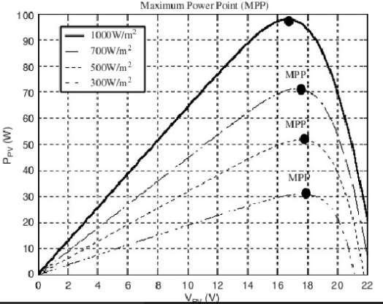

Fig.2.2 Maximum power point

One may determine the MPP using Figure 4. It is frequently utilised when looking for it with various methods. For example, the perturb and observe approach, incremental conductance algorithm, parasitic capacitances, constant voltage control, constant current control, pilot cell, and artificial intelligence method are some of the various algorithms used in tracking the MPP according to the P&O method, when the operational voltage of a PV panel is perturbed by a little amount, the consequent change in power P is positive, and we are then moving in the direction of MPP, we continue perturbing in the same direction. If the P is negative, we are moving in the opposite direction of the MPP, hence we must modify the given perturbation's sign.

The P&O algorithm flow chart.

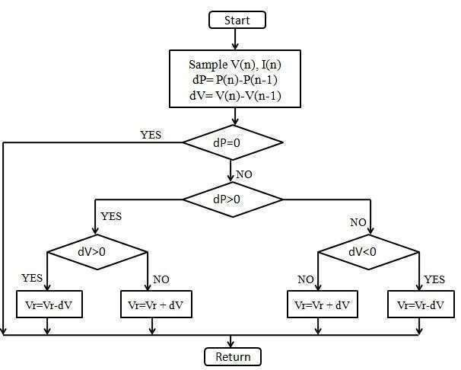

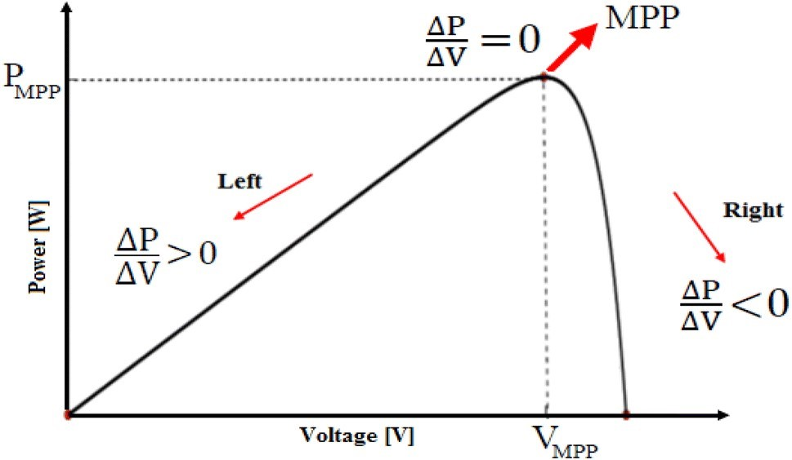

Fig.2.3 flow graph

The main flaws of the P&O algorithm are oscillations about the MPP during steady state operation and sporadic departures from the maximum operating point under quickly varying atmospheric circumstances, like breaking clouds. In order to deliver acceptable performance in both dynamic and steady-state response, the proper perturbation size is also crucial to reduce these shortcomings, a number of variants of the standard P&O have been suggested. These include taking an average of numerous samples of the array power and dynamically modifying the magnitude of the perturbation M of the PV operating point.

**2.3 Incremental conductance (INC) method**

This is due to the fact that at the MPP, the slope of the PV array power versus voltage curve is zero. This approach has been suggested as a way to overcome the P&O algorithm's shortcomings by enhancing tracking precision and dynamic performance under rapidly changing situations. Figure 10 illustrates the INC MPPT method's flowchart by computing the sign of dP/dV without a perturbation using the PV array's incremental conductance. It accomplishes this by employing a formula that is derived from the requirement that dP/dV = 0 at the MPP. From this presumption, it is possible to demonstrate that at the MPP dI/dV = -I/V. Therefore, incremental conductance can detect when the MPPT has reached the MPP and stop causing operating point perturbation. If this criterion is not satisfied, it is possible to determine, using the relationship between dI/dV and I/V, the direction in which the MPPT operating point must be perturbed. The fact that dP/dV is negative when the MPPT is to the right of the MPP and positive when it is to the left of the MPP leads to the development of this connection. The advantage of incremental conductance over the perturb-and-observe algorithm is calculation of the perturbation direction to apply to the array's operating point in order to reach the MPP, as well as the ability to determine when it has truly reached the MPP. As a result, it can follow quickly growing and dropping irradiance conditions with more accuracy under rapidly changing settings than perturb and observe. Due to the resolution of digital implementation, the slope of the PV array power versus voltage curve rarely has a null value. Despite being slightly more complex than the P&O algorithm, the INC approach can be implemented with ease thanks to developments in digital signal processors.

**2.3.1 DRAWBACKS**

The usage of a set step to get to the ideal position is the fundamental reason for these drawbacks. Even if, in a steady state, using a tiny step is more effective, the searching process must be sped up by using a bigger step. Instead of using a fixed step, the current paper proposes the use of a variable one. A step like this one is big in the start of the process, average in the middle, and little when it is stable. This phase is produced using a fuzzy logic-based block.

**`2.4 FUZZY LOGIC ALGORITHM**

Fuzzy logic has been based on human decision-making and can present good efficiency or acceptable output without knowing a precise mathematical model where the inputs are inaccurate and ambiguous. As can be seen in , fuzzification, rule base, inference engine, and defuzzification are the four major and essential steps in implementing any fuzzy system. In most research conducted so far, the fuzzy toolbox of MATLAB software has been used to design a fuzzy system and create membership functions and rule bases . This will lead to a proper response and will be effective only when there are adequate knowledge and the necessary solar systems expertise. Hence, the possibility of error incidence in the fuzzification of variables using this method is very high. Further, the alteration of membership functions to achieve the desired outcome will be time-consuming. This is why in some studies, fuzzy logic has been described as a method with complexity and difficulty, which is required prior knowledge about the system to implement. In this paper, unlike previous research to enhance the accuracy and reliability of the system, the fuzzy toolbox has not been used. On the other hand, fuzzy logic has been applied in a novel way to improve its performance and facilitate applying changes in its different sections. In this way, all the steps of implementing the fuzzy logic have been coded in MATLAB M-files. In this regard, fuzzification of variables, the formation of the rule bases as well as all the other steps have been created independently of human knowledge and experience about the solar system through mathematical and fuzzy sets relations, and without using common linguistic values such as negative big (NB), negative small (NS), zero (ZO), positive small (PS), positive big (PB), etc. The various steps of implementing the fuzzy system are as follows. Two common shapes of membership functions (i.e., triangular and gaussian types) have been created by mathematical relations and employed to fuzzify the variables. This feature helps us change each variable’s membership function to get the best results. Additionally, Changing the number of membership functions has also been considered as an option in the system design. Then, the degree of membership of each variable’s values is calculated in membership functions by feval function. After this, the fuzzy sets relations have been applied to create rule bases (i.e., Mamdani’s product implication and t-norm), the code was written so that all the possible combinations of input and output membership functions are created. In other words, all the possible rules are made. After making all the available rules, the correctness of each rule is calculated by Mamdani’s product implication method. According to the written code, each rule, which had a higher score, was selected as one of the basic rules. On the other hand, the rules that had a lower score were deleted. Eventually, a fuzzy inference system based on Mamdani algorithm is created using the fuzzy logic toolbox’s functions. This system receives variables as well as membership functions and rules that have been made through addvar, addmf, and addrule functions so that this section be completed. All the above steps are implemented in a function’s form. The function is then connected to another M-file, where it is only needed to enter the variables, the number of membership functions as well as the type of them. In this way, the fuzzy system design is finished.

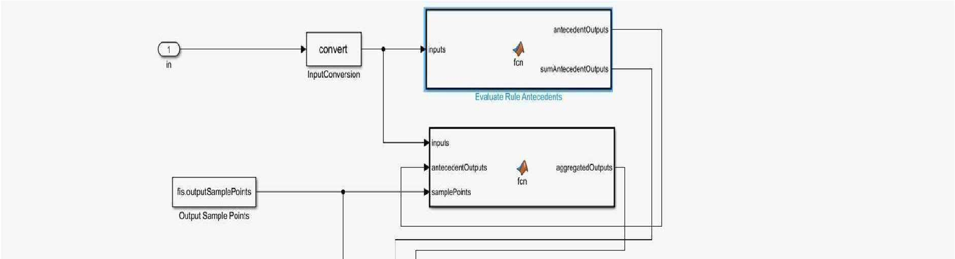

Fig.2.4 Fuzzy logic controller

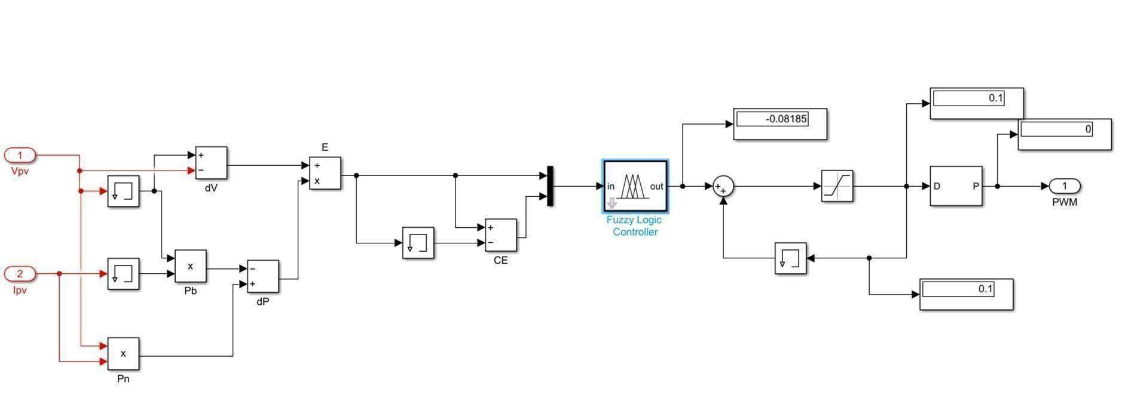

Fig.2.5 Fuzzy logic MPPT block

**Chapter-3**

**CONTROLLER AND RESULTS**

The word "control" and its several synonyms are widely used in ordinary discourse. A situation can be controlled, for example, by a police officer directing traffic or a firefighter putting out a fire. Alternatively, a dispute could arise. Something bad could happen to us due to events beyond our control. The word "control" naturally connotes the return to a desired state that has been disrupted by internal or external factors. There are control processes in the broadest range of fields. For instance, control mechanisms safeguard plants and animals in nature from a variety of environmental hazards. In economics, supply and demand determine a product's price and time of delivery. Disturbances could happen in any of these scenarios and alter the state that was first formed. It is an attribute of the control mechanism to identify disturbed states and use the proper means to fix them PI controllers are often employed in practice. In this combination, one P and one I controller are connected in parallel (Fig. 4.1). If properly designed, they combine the advantages of both controller types (stability and rapidity; no steady-state error), so that their disadvantages are compensated for at the same time.

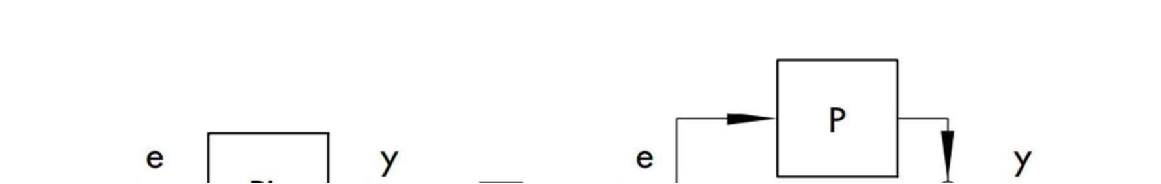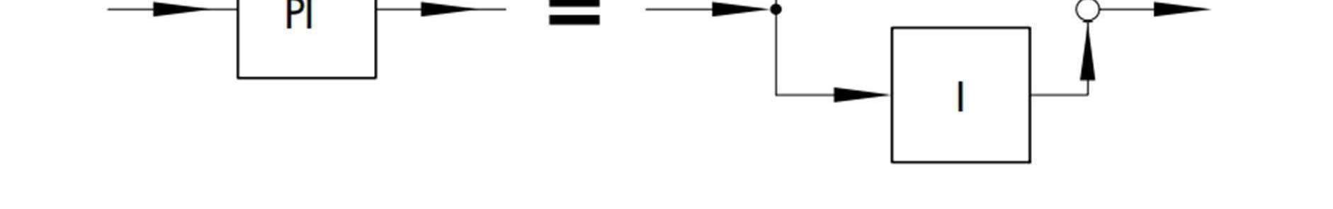

Fig.3.1Elements of PID controller

The proportional-action coefficient KP and the reset time Tn serve as indicators of dynamic behaviour. The controlled variable responds instantly to any error signal because of the proportional component, but the integral component takes some time before beginning to acquire power. Tn is the amount of time it takes for the I component to produce the same amount of control amplitude that the P component (KP) did at the beginning. If the integral-action component is to be increased, the reset time Tn must be shortened, much like with I controllers a very flexible PID controller is created when a D component is introduced to PI controllers. When tuned properly, the additional D component, like PD controllers, makes the controlled variable closer to its set point so that steady state is reached more quickly.

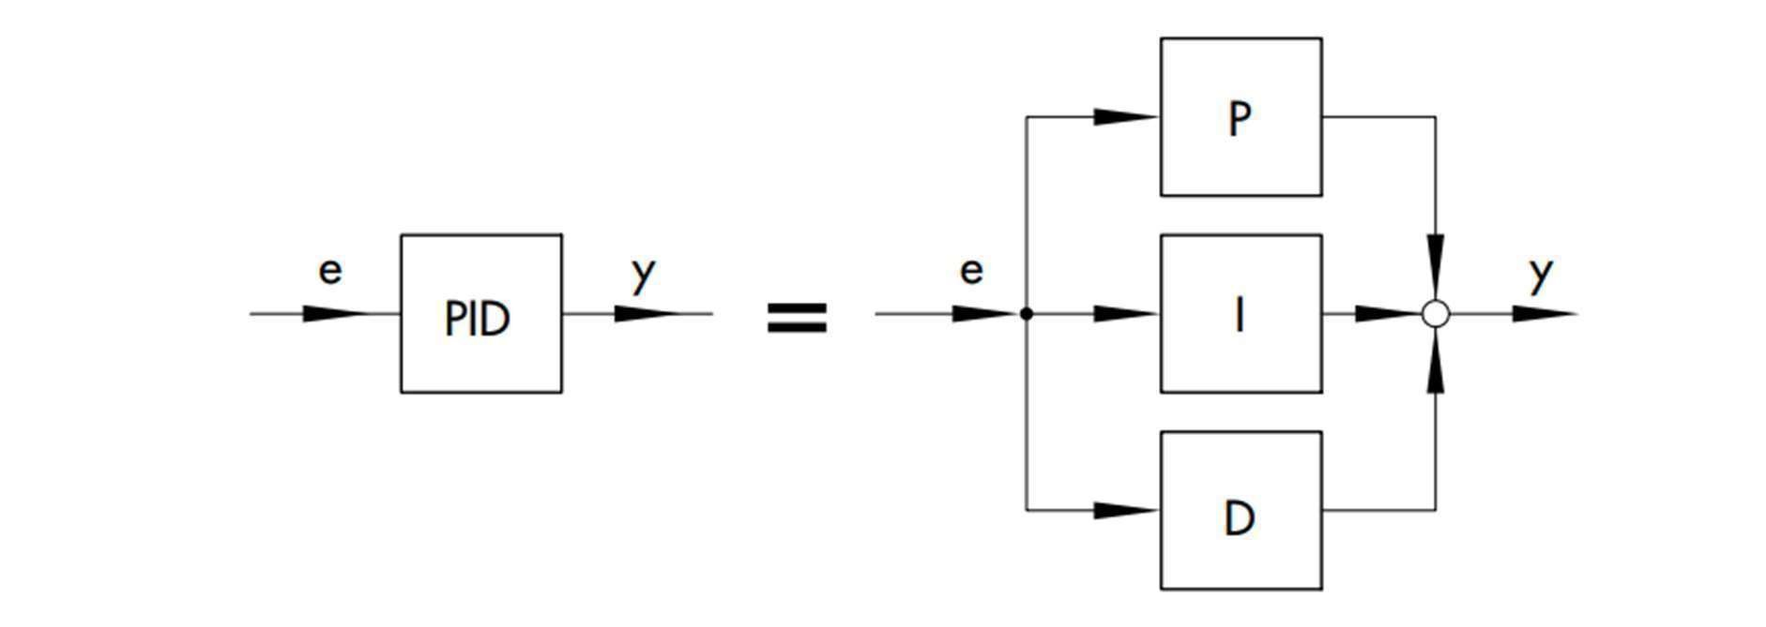

Fig.3.2 PID controller

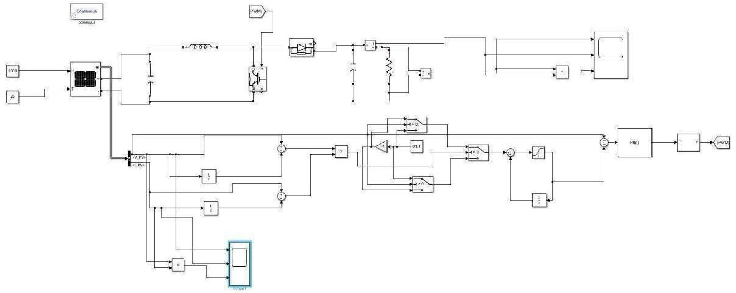

Fig.3.3 P&O MATLAB Simulation

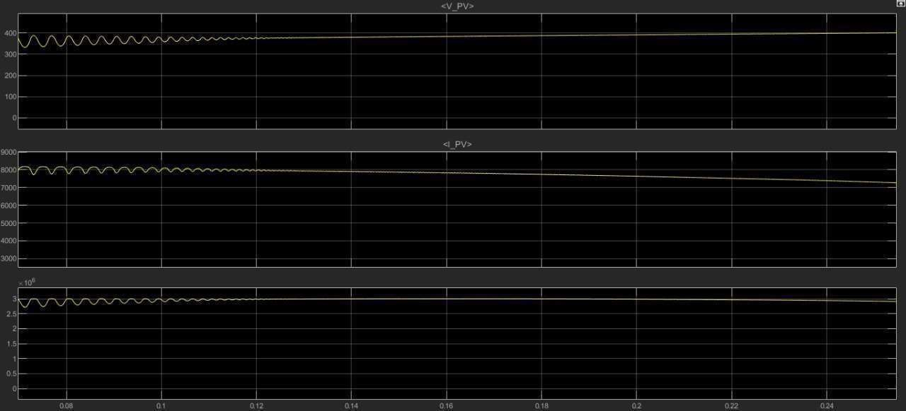

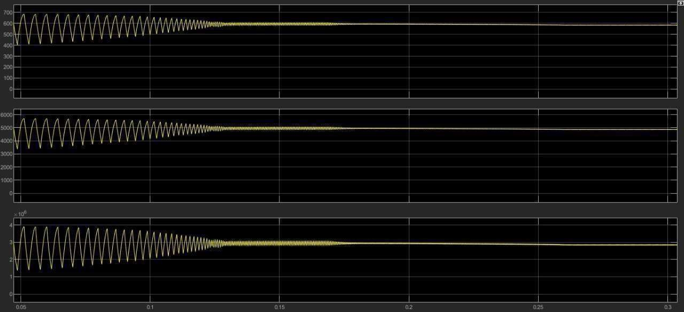

Fig.3.4 Input/output voltage, current and power waveform

#### Fuzzy logic controller based MPPT Model

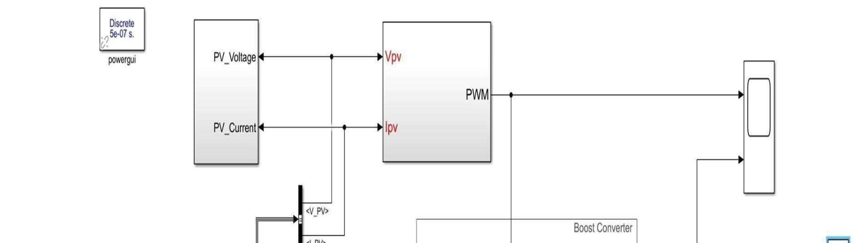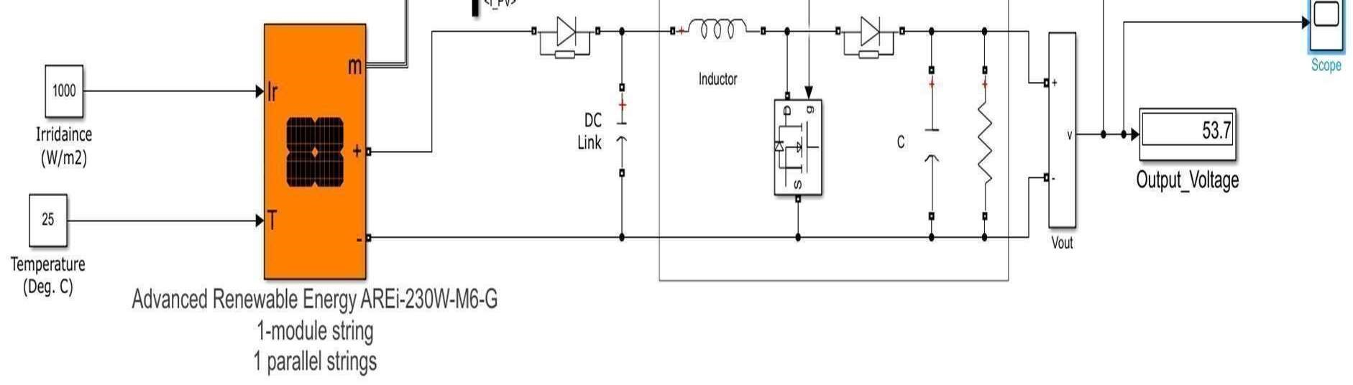

Fig.3.5 Fuzzy logic controller MATLAB Simulation model

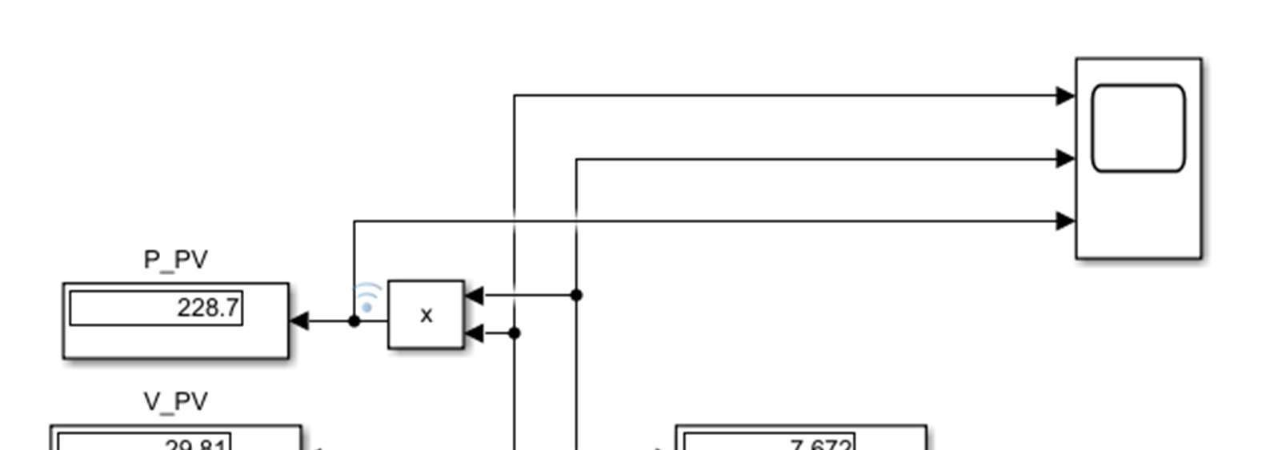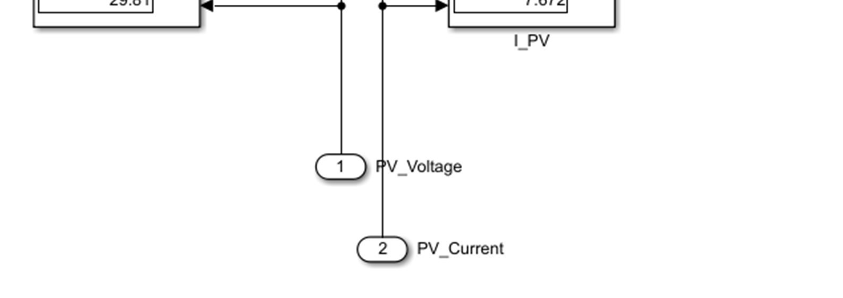

Fig.3.6 voltage and current measurement

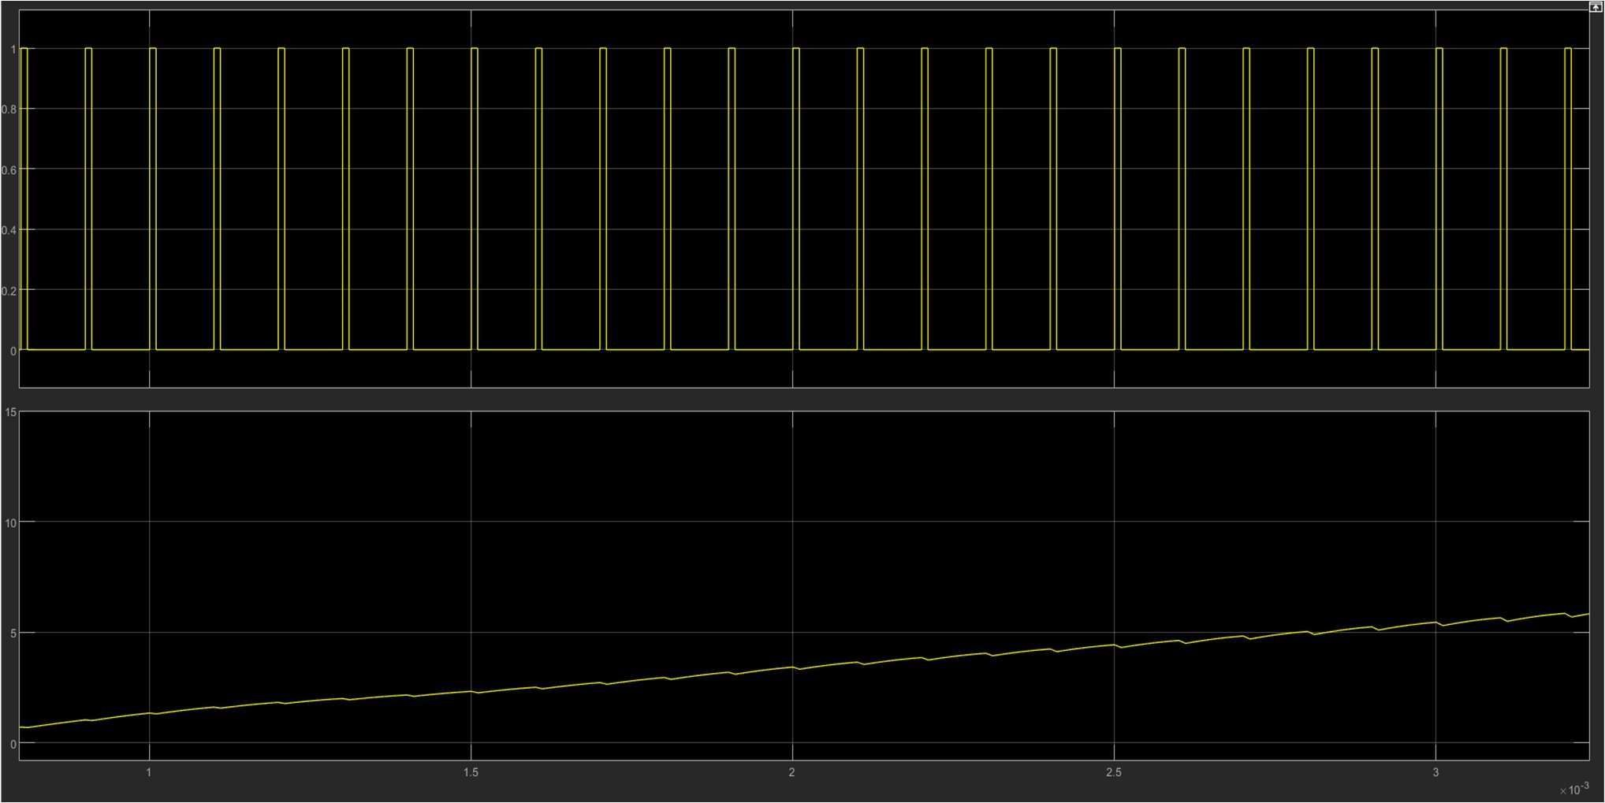

Fig.3.7 Output voltage and PWM waveform

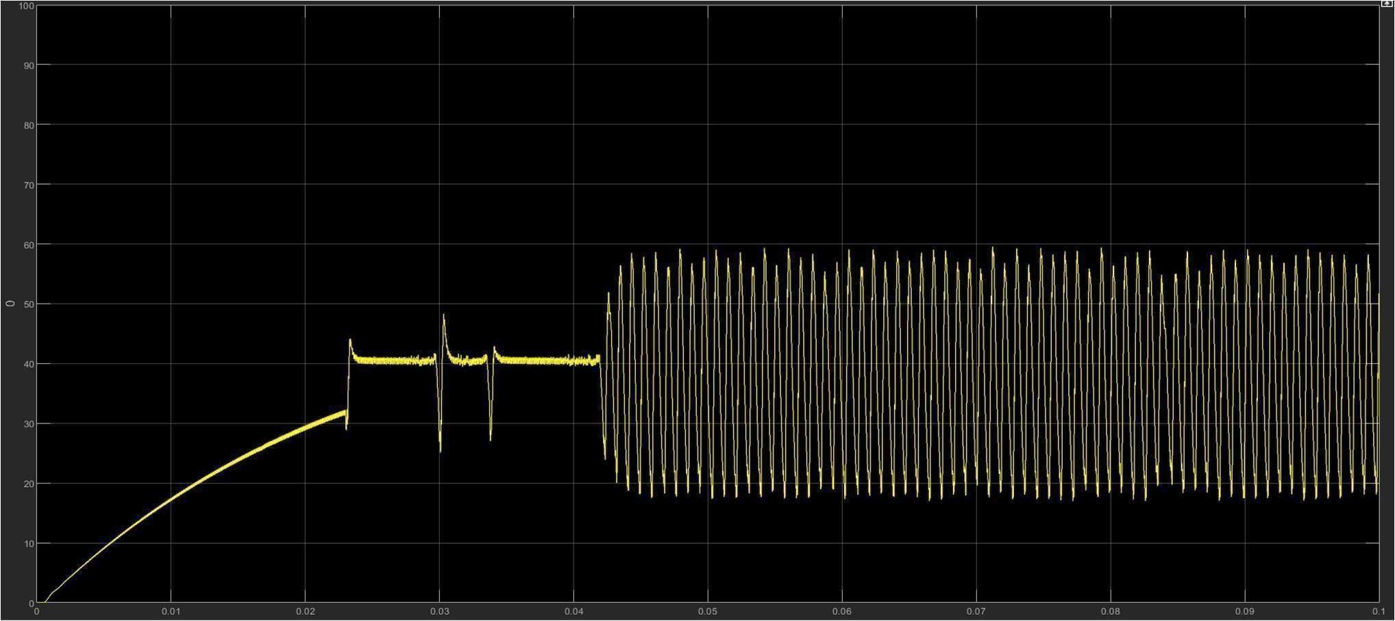  
 Fig.3.8 output voltage waveform

## Chapter-4

### CONCLUSION

This report is highly dedicated towards different types of algorithms and techniques that we have used to track the maximum power point in the PV array. Starting from the very beginning of this report, we have discussed about various important points regarding photovoltaic system. And after discussing about PV system , we then moved to our next topic which is related to the different types of components that we have used in our project like- different types of converters, PI and PID controllers, different simulation blocks in the MATLAB etc. After going through basics of PV arrays and different components, we have discussed about concept of MPPT and various algorithms that we have used to track maximum power. First concept used was Perturb and Observe technique but here we were encountered by some of the problems of irregular irradiation and partial shading. The said problems were then catered by using two other techniques i.e Particle swarm optimization and Fuzzy controller technique. Apart from the three techniques that we have used in our model, we have also tried to develop some more methods to optimize the problems related to maximum power point tracking and fortunately also successfully did it theoretically till the publishing of this report. We have developed two new techniques namely- curve equation algorithm and average iteration algorithm. All the algorithms have been verified and successfully conducted using MATLAB and results were also attached.

The effort of this project has been always to solve the problems catered in the field of MPPT and this project has a promising future with application in different fields across the globe. Few of the futuristic scope are comparing different MPPT techniques and the proposed network.

1. Studying the effect of the hysteresis current control method and its effect on power quality from the utility grid point of view its well-known that various types of methods is used for generating electricity like Thermal Power plants (Nuclear, Coal, petroleum etc.), Hydro (water) power plants, but it is non-renewable resources and also harmful for humans as well as the environment. As many types of other charge controllers like PWM etc. also available, but due to low efficiency it cannot be used completely by the consumers. Hence there is need to develop more other cheap and effective MPPT algorithms so that almost 100% efficiency can be achieved. Here are the some that can be future research papers:

2. MPPT operating APP: An application of operating MPPT by the help of smartphones can so be made opto rate from whenever via the Internet.

3. DC-DC running loads: DC from MPPT can be taken directly and DC load can be run. DC loads help some low electricity.

4. Energy Management: There is a need to manage energy when these algorithms are developed.

**REFERENCES**

[1] Ali AI, Sayed MA, Mohamed EE. Modified efficient perturb and observe maximum power point tracking technique for the grid-tied PV system. Int J Electr Power Energy Syst 2018.

[2] Solangi K, Islam M, Saidur R, Rahim N, Fayaz H. A review on global solar energy policy. Renew Sustain Energy Rev 2011.

[3] Sayed MA, Mohamed E, Ali A. Maximum power point tracking technique for grid-tie PV system. In 7th international middle-east power system conference (MEPCON’15), Mansoura University, Egypt; 2015.

[4] Ali AIM, Sayed MA, Takeshita T, Hassan AM, Azmy AM. A single-phase modular multilevel inverter based on controlled DC-cells under two SPWM techniques for renewable energy applications. Int Trans Electr Energy Syst 2020.

[5] Hanzaei SH, Gorji SA, Ektesabi M. A scheme-based review of MPPT techniques with respect to input variables including solar irradiance and PV Arrays’ temperature. IEEE Access 2020.

[6] Nofuentes G, Gueymard C, Aguilera J, P ́erez-Godoy M, Charte F. Is the average photon energy a unique characteristic of the spectral distribution of global irradiance? Sol Energy 2017.

[7] Gunasekaran M, Krishnasamy V, Selvam S, Almakhles DJ, Anglani N. An Adaptive Resistance perturbation-based MPPT algorithm for photovoltaic applications. IEEE Access 2020.

[8] Hirata Y, Aihara K. Improving time series prediction of solar irradiance after sunrise: comparison among three methods for time series prediction. Sol Energy 2017.

[9] D. C. Huynh, T. N. Nguyen, M. W. Dunnigan and M. A. Mueller, “Dynamic particle incremental conductance algorithm based maximum power point tracking of solar photovoltaic panels,” IEEE International Symp. Industrial Electronics 2013.